**WIC** **File** **Changes Analysis**

1. **Wic change in sprint**:
2. File path change

+ Old: /appl/batchinputs/J50X100/WICTX.TXT

+ New : APL/HCL files located in /common04

* /appl/batchinputs/J50X100/ common04/ APL,HCL files

+**Question**:

* Change path for only Wic file?

1. File type change

+ Use APL/HCL files new change for TXT file old

+**Question**:

* Is name file change? Old file is WICTX.TXT

(MDYYHHMM.XXX (APL or HCL file). A UPC/PLU store file (APL) or Hot Card List file created by the WIC State Agency)

* Use cả 2 file APL/HCL for run WIC ?

1. New records on APL

+ Handle 3 new record, xem ở phần II, III

1. **Fomat file change**:
2. **Header**:

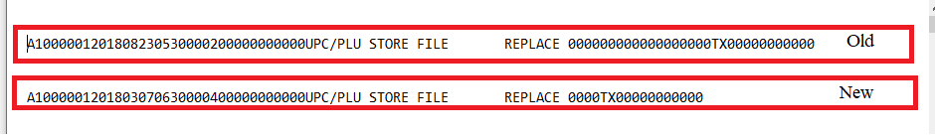+ Has change data format but in code only check start with character “A” for check is header of file => not important

1. **Body**:

+ Has change data format :

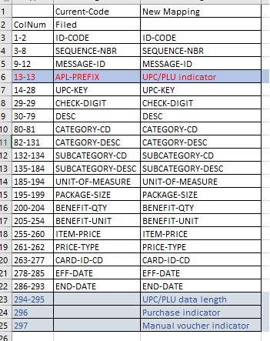

+ **Question**:

* Filed APL-PREFIX and filed UPC/PLU Indicator khác gì nhau không?
* Vẫn sữ dụng filed UPC/PLU Indicator như filed APL-PREFIX để check và insert into column “wic_apl_id” on “prod_scn_cd_wic” table ?

1. **Footer**

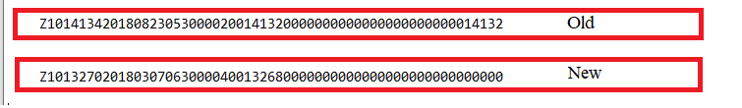+ Has change data format but in code only check start with character “Z” for check is footer of file => not important

1. **New Format data with “D6”**

**+ Question:**

* Format này có dùng hay k?
* Có phải format này dùng để add only Category/Sub-Category?

1. **Wic data add new records on APL**:
2. Purchase Indicator

+ Purchase indicator has value at position 296 in record input.

+ Handle data and insert into DB:

* Purchase indicator = ‘0’ insert one entries with Category, Sub-category in record
* Purchase indicator = ‘1’ insert two entries for the same UPC/PLU
* 1 for specific Sub-Category: UPC, Category, Sub-category in record
* 1 for Broadband Sub-Category: UPC, Category, Sub-category (“000”)

**Question**:

**+** IfPurchase indicator = ‘1’ and Sub-category in record is Broadband Sub-Category(“000”) => insert one record ?

**+** Broadband Sub-Category có phải là Sub-category in “D6”? Nếu k có info for Sub-category (“000”) thì xữ lý sao?

* Purchase indicator = ‘2-9’ insert one entries with Category, Sub-category in record ?

1. Manual Voucher Indicator

Manual voucher indicator has value at position 297 in record input. Manual voucher has value is 0-9 and manual vouchers are used by the WIC Vendor; default is “1”, default value for smart card APL files is “0”.

+**Question**:

* Manual Voucher Indicator maping ở đâu trong DB?
* How to xác định Smart card APL ? Nếu in record Manual voucher indicator is “1” for smart card APL thì mình có set về lại “0” k, hay validate và báo lỗi?

1. UPC/PLU Data Length:

Length of UPC or PLU (including check digit) that must also be reported back in the claim file. Valid values are 5 or 6 for PLU’s; 12, 13 or 14 for UPCs.

* Option 1 – store this value from each APL record for BI to report in the daily WIC claim files
* Option 2 – Have BI count the number of significant digits (including check digit and excluding leading zeroes) for each UPC/PLU and report as follows:
* 5 for PLU’s with 5 digits (including check digit) where PLU Indicator equal to 1
* 6 for PLU’s with 6 digits (including check digit) where PLU Indicator equal to 1
* 12 for UPC’s with 1 to 12 significant digits (including check digit) where PLU Indicator equal to 0
* 13 for UPC’s with 13 significant digits (including check digit) where PLU Indicator equal to 0
* 14 for UPC’s with 14 significant digits (including check digit) where PLU Indicator equal to 0
* Sẽ phải có UPC/PLU length trong claim file gì đó do BI send

+ **Question**:

* Mình có validate gì cái length của UPC/PLU với cái UPC/PLU length này K?
* With option 1: có 2 option k biết dùng cái nào

1. Mình lấy UPC/PLU length and add to file send for POS, sau đó Pos send for BI?
2. Mình lấy UPC/PLU length in file and save to DB and Bi sẽ lấy đó để add vào report?

* With option 2:

Bi sẽ count the number và mình k cần làm gì cả?????

**\*** WIC file daily có phải là file daily WIC claim không?

1. **Note**:

* What is WIC Online EBT, WIC Smart Card EBT ? How to xác định WIC Online EBT, WIC Smart Card EBT?
* In some implementations based on prior file formats, the *Purchase indicator* may not be present in the WIC UPC/PLU store file (APL). If the *Purchase indicator* is not present in the UPC/PLU store file (APL) detail record for a UPC and there is only one instance of the UPC, then the Broadband Sub-Category '000' shall be treated as if the UPC/PLU for the food item had a *Purchase Indicator* of “0” restricting redemption to the specified subcategory.

*=> Trong mapping file filed Purchase indicator is mandatory nên sẽ k empty, vậy trường hợp này có cần check k hay validate and show error thui.*